|  |  |
| --- | --- |
| **Computer Science 1** | **Lab 05B**  **1-Day Minor Python Assignment** |
| **Turtle Graphics Maze** | **60, 70, 80, 90 and 100 Point Versions** |
| **Assignment Purpose:**  Students will practice the same skills needed to make a robot move by navigating the Python “Turtle” through a maze. | |

For this assignment, you are provided with a partially written program that displays the maze which is shown below:

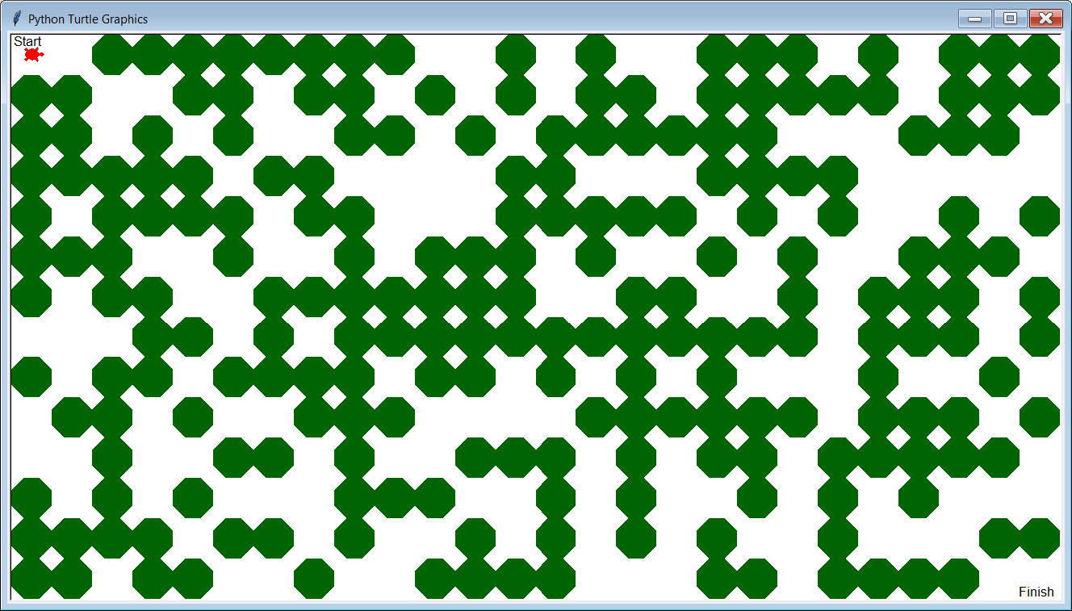

|  |  |
| --- | --- |
| At the top-left corner of the graphics window, right under the word “**Start**” you will see a red turtle. Normally, the “turtle” in *Turtle Graphics* looks like a small triangle; however, if you use the **shape(“turtle”)** command, you can make the “turtle” look like an actual turtle. |  |

For this assignment, your mission is to make the “turtle” find its way through the maze until it reaches the “**Finish**” point in the bottom-right corner of the graphics window. You will do this by using many **forward**, **right** and **left** commands.

When you look at the provided file, you will see that a library called **Maze** is imported. This is a special library that was created to generate the maze. You will also notice the presence of a file called **Maze.py**. Yes, this is the **Maze** library. DO NOT MAKE ANY CHANGES TO THAT FILE!

|  |  |
| --- | --- |
| **Lab 05B Student Version** | **Do not copy this file, which is provided.** |
| **1 # Lab05Bst.py  2 # "Turtle Graphics Maze"  3 # This is the student, starting version of Lab 05B.  4   5   6 from Maze import *   7 from time import sleep  8   9  10 setup(1310,710) 11 drawMaze() 12 shape("turtle") # Makes the "turtle" look like a turtle 13  14 ############################################ 15 # DO NOT CHANGE ANYTHING ABOVE THIS BOX. # 16 ############################################ 17  18 sleep(2) # Makes the turtle wait 2 seconds before it moves. 19 speed(3) # Controls turtle speed. speed(0) is the fastest. 20  21  22  23  24  25  26  27  28  29 ############################################ 30 # DO NOT CHANGE ANYTHING BELOW THIS BOX. #  31 ############################################ 32  33 update() 34 done() 35** | |

**NOTE: Do NOT attempt to do the entire program all at once. Write just a 1 or 2 lines of code at a time and keep testing your program, making adjustments as you go.**

Also, on line 19, you can change the **speed** value to **0** to “speed up” the “turtle”.

**100 Point Version Specifics and Output**

You need to make the turtle navigate its way through the maze as shown below.

You do not need to follow the exact path shown here. There is more than one way to solve this maze.

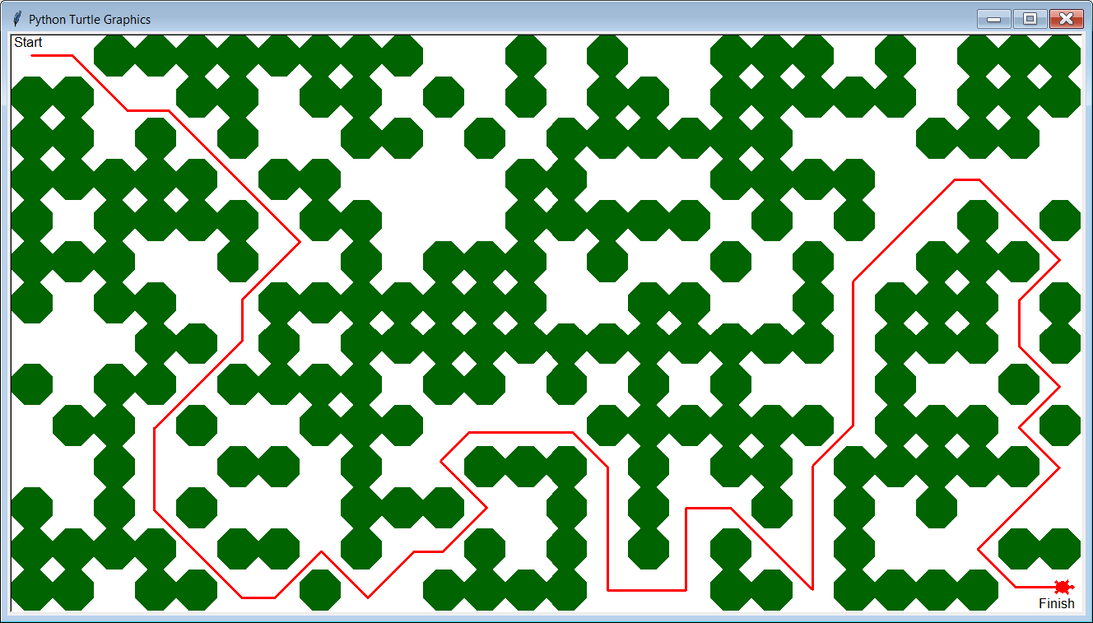

You will not receive credit if any part of the red path crosses or even touches any of the green octagons.

The turtle needs to finish right above the word “**Finish**” and he needs to be facing to the right.

If your “turtle” does not navigate the entire maze, you can still earn partial credit (60, 70, 80 or 90 points) by completing part of the maze. The breakdown is shown in the next 4 outputs.

**90 Point Version Specifics and Output**

Your turtle does not navigate the entire maze, but at least makes it this far:

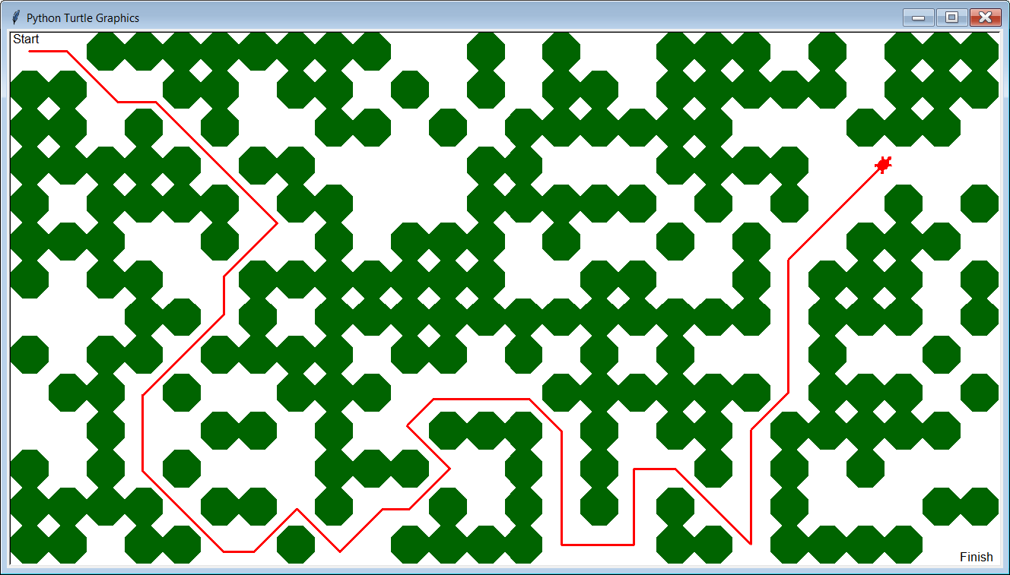

**80 Point Version Specifics and Output**

Your turtle does not navigate far enough to earn a 90, but at least makes it this far:

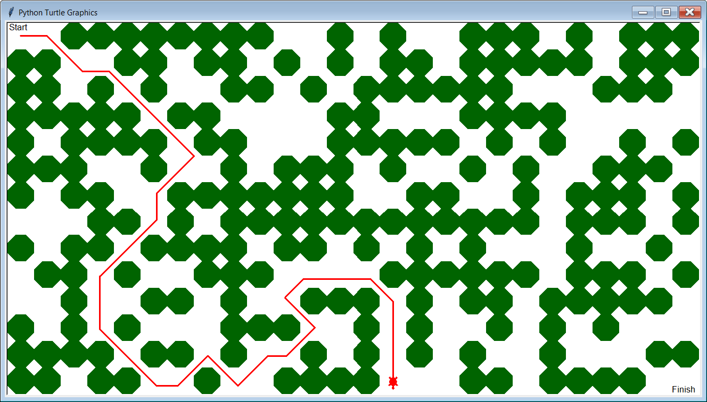

**70 Point Version Specifics and Output**

Your turtle does not navigate far enough to earn an 80, but at least makes it this far:

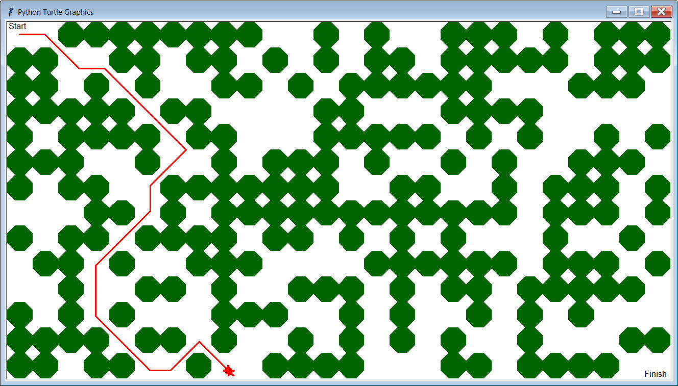

**60 Point Version Specifics and Output**

Your turtle does not navigate far enough to earn a 70, but at least makes it this far:

